Entities & Relationships
We designed 6 entities:
- User authenticated users
- Site available sites
- Device devices of the site
- Subscription users list of reserved metrics
- Metric Metrics of the devices, subscribed Metrics of the user
- Permission user‘s authorized sites , site‘s authorized users
They will be described later in detail
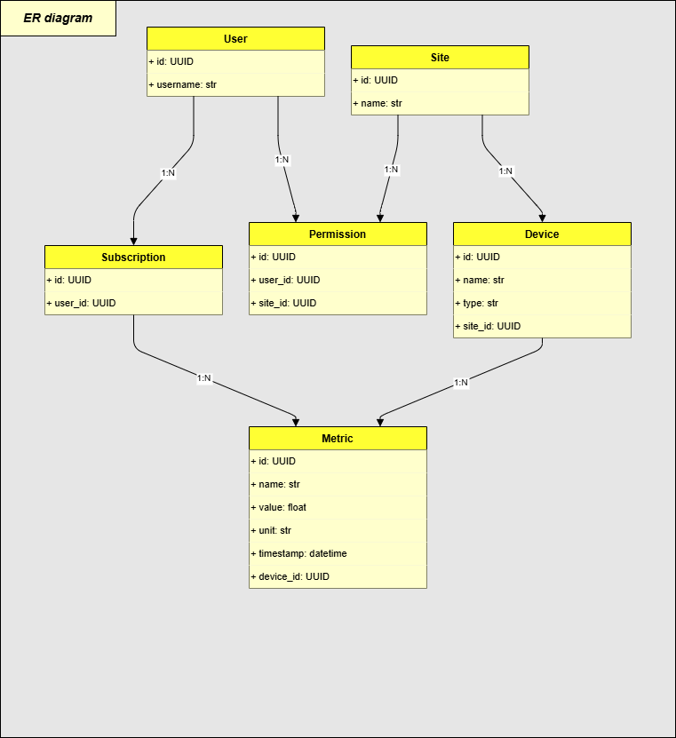

1. User
- Fields: id, username, role
- Purpose: Authenticated actor making API requests
- Relations:
  - Has many Permissions
  - Has many Subscriptions
- Note: it‘s good idea to have role entity with with many to many relationship with user valid in range time form and time to as so as with site

2. Site
- Fields: id, name
- Purpose: Represents a physical location
- Request: R1
- Relations:
  - Has many Devices
  - Access controlled by Permission

3. Device
- Fields: id, name, type, site_id
- Purpose: A device reporting metrics
- Request: R2
- Relations:
  - Belongs to one Site
  - Has many Metrics

4. Metric
- Fields: id, name, value, unit, timestamp, device_id, subscription_id
- Purpose: Measurement from a device
- Request: R3 , R5
- Relations:
  - Belongs to one Device
  - Belongs to zero or one Subscription
- Note: the Metric may have max one subscription so the the history is determined by time range and metric. If subscription would have time range so this history may be filtered by this range.
At this moment, we are abstracting away from the historical measurements (r5) of a given metric; naturally, this would involve a dedicated measurements table.

5. Subscription
- Fields: id, user_id
- Purpose: Registers interest of a user in certain metrics
- Request: R4
- Relations:
  - Belongs to one User
  - Connected to many Metrics
- Note: now there is only one subscription for particular metric.. its reasonable to have time form and time to when it is valid.

6. Permission
- Fields: id, user_id, site_id
- Purpose: Controls access to specific Sites for a user
- Request: R1
- Relations:
  - Belongs to one User
  - Belongs to one Site
- Note: now there is only one Permission for particular tuple (user,site) it‘ s reasonable to have time form and time to when it is valid.

Energy Management API
1.0.0
OAS 3.1
/openapi.json
RESTful API for managing energy Sites, Devices, Metrics and Subscriptions.
- **Standard Users** can view their Sites and Metrics.
- **Technicians** can create/update/delete Devices.
- **Metrics** are exposed with metadata and latest values.
provide time series of measurement.
- **Subscriptions** allow access to particular set of Metrics.

Here reader may find the list of exposed restAPI
it is described in detail in the site <BASIC_URI>:<PORT>/doc

Sites
GET
/sites/
List Sites
GET
/sites/{site_id}
Get Site

Devices
POST
/devices/site/{site_id}
Create Device
GET
/devices/{device_id}
Get Device
PUT
/devices/{device_id}
Update Device
DELETE
/devices/{device_id}
Delete Device

Metrics
GET
/metrics/{metric_id}/latest
Get Latest Metric
GET
/metrics/{metric_id}
Get Metric History

Subscriptions
GET
/subscriptions/
Get Subscriptions
POST
/subscriptions/
Create Subscription
PUT
/subscriptions/{subscription_id}/assign/{metric_id}
Assign Metric

